LDA Assignment

Cade Muntz

**Overview**

We have been hired by a local bar (Crowbar) in Corvallis, Oregon to help them understand how the local population perceives their bar. They would also like to be able to see how the competition performs in relevant areas in which Crowbar tries to compete. The task we have been given is to survey a few of Crowbar's customers to see how they perceive Crowbar in relation to other local bars in the area. To understand how their customers perceive their bar in relation to others, we will be running a Linear Discriminant Analysis (LDA.) This is the best model for this task as an LDA will help us understand where Crowbar ranks in different variables compared to others. Essentially, we will be able to see Crowbars strengths and weaknesses in relation to other bars.

**Initial Insights**

To begin with this task, we wanted to start by seeing how customer’s perceived Crowbar alone. We did this by running the summary statistics of Crowbar along with the survey variables that were asked to customers. In regards to these variables, customers were asked to rate each bar on a scale of 1-7 using the following metrics:

* GoodPrice - Does the bar have good pricing
* FoodQual - How good the food quality is at the bar
* FoodSel - How good the food selection is at the bar
* DrinkQual - How good the drink quality is at the bar
* DrinkSel - How good the drink selection is at the bar
* Chill - How relax / “Chill” the environment is within the bar
* Clean - How clean the bar and seating area within the bar is
* OutSeating - How much outdoor seating the bar has

The variable Bar Name is the variable in which we are testing these descriptive variables against.

**Summary Statistics**

The summary statistics provided us results into Crowbar's average score for each variable on the 1-7 scale. Based on the results Crowbar's strengths seem to be - Good Price, Food Quality, Drink Selection, Chill environment, and Outdoor Seating. Their main weaknesses seem to be Food Selection, Drink quality, and Cleanliness.

When comparing these summary statistics to other bars we can see that Crowbar is at the top for Good Price and Drink Selection, and Chill as well as being close to the top on Food Quality and Outdoor Seating. Whereas, in Food Selection, Drink Quality, and Cleanliness they perform the worst.

**Linear Discriminant Analysis**

Using the data we will be running an LDA ( Linear Discriminant Analysis) to help us better understand what Crowbar's strengths and weaknesses are compared to their competitors. This analysis will create a spectrum of variables based on the 1-7 scale and group the bars based on this spectrum. For example, one of the functions could create a spectrum where on one side Good cleanliness and poor food quality are on one side, whereas on the other side it would be bad cleanliness and good food quality. If a bar lands closer to one side, that is what consumers think about said bar.

**LDA Initial Insights**

When it comes to running an LDA we need to figure out how many canonicals we will use. Each canonical produces a new spectrum with different defining characteristics that make up the spectrum. Upon running our initial model of 2 canonicals we see that adding a third canonical produces an eigenvalue of 1.9946. In relation to the proportion, we are missing out on 21.33% of the data being represented with only 2 canonicals. However, having 4 canonicals would only produce an eigenvalue of 0.4383 and a proportional coverage of an additional 4.6%. This is a pretty insignificant percentage and not worth creating a 4th canonical to represent this. Therefore, our model will have 3 canonicals.

**Understanding the model**

Upon running an LDA with 3 canonicals, we output 3 different functions that each have their own characteristics. The chart below shows the weight makeup of each canonical which will be used to better understand what each canonical means.

| Total Canonical Structure | | | |
| --- | --- | --- | --- |
| Variable | Canonical 1 | Canonical 2 | Canonical 3 |
| GoodPrice | 0.851 | 0.129 | 0.047 |
| FoodQuality | -0.211 | 0.668 | 0.467 |
| FoodSelection | -0.654 | 0.158 | 0.444 |
| DrinkQuality | 0.056 | -0.225 | -0.173 |
| DrinkSelection | 0.367 | 0.813 | -0.174 |
| Chill | -0.104 | 0.253 | -0.421 |
| Clean | -0.863 | 0.093 | -0.257 |
| OutSeating | 0.216 | -0.121 | 0.855 |

Based on this Chart the Canonicals can be described by different characteristics

* Canonical 1 can be described as having good prices, poor food selection, and poor cleanliness
* Canonical 2 can be described as having good food quality and good drink selection
* Canonical 3 can be described as having a good chill environment and good outdoor seating

Drink Quality was the only variable that did not seem to fit any canonical as it is not weighted very highly, meaning none of the canonicals is a very good fit for it. Using the canonical definitions we can plot a few charts which will help show what being in each canonical means for the bars.

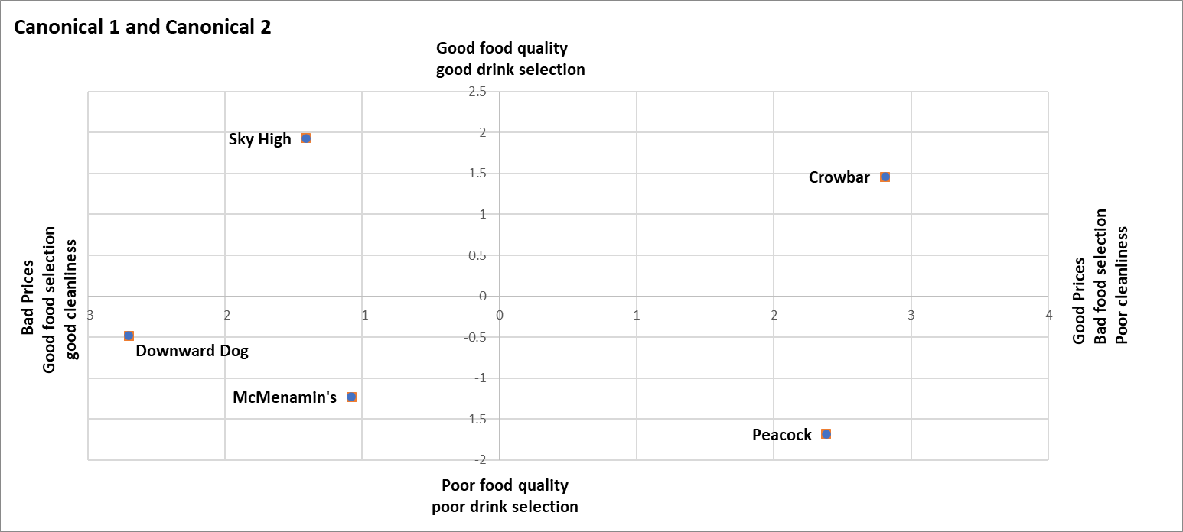

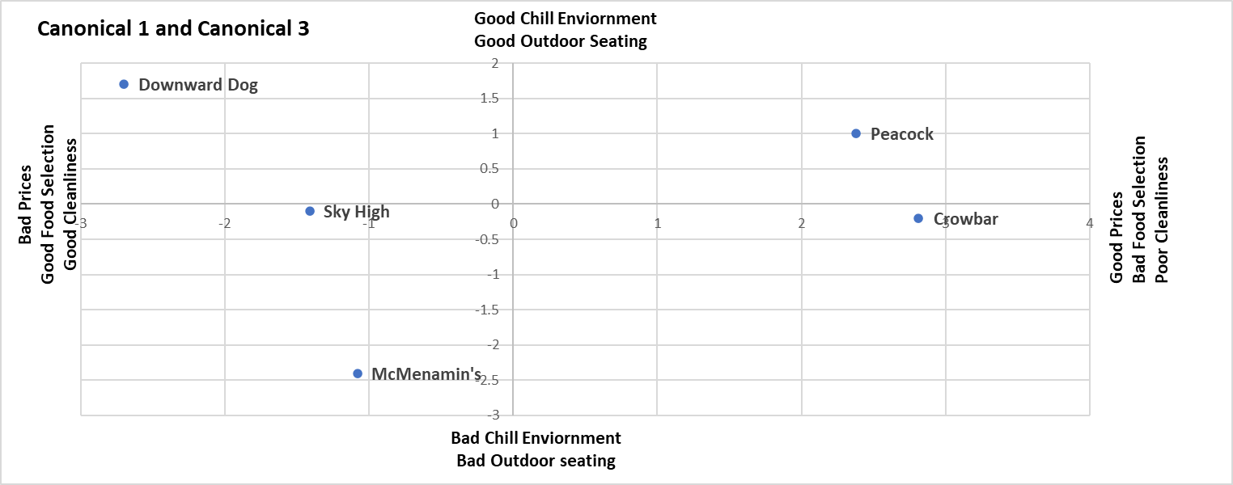

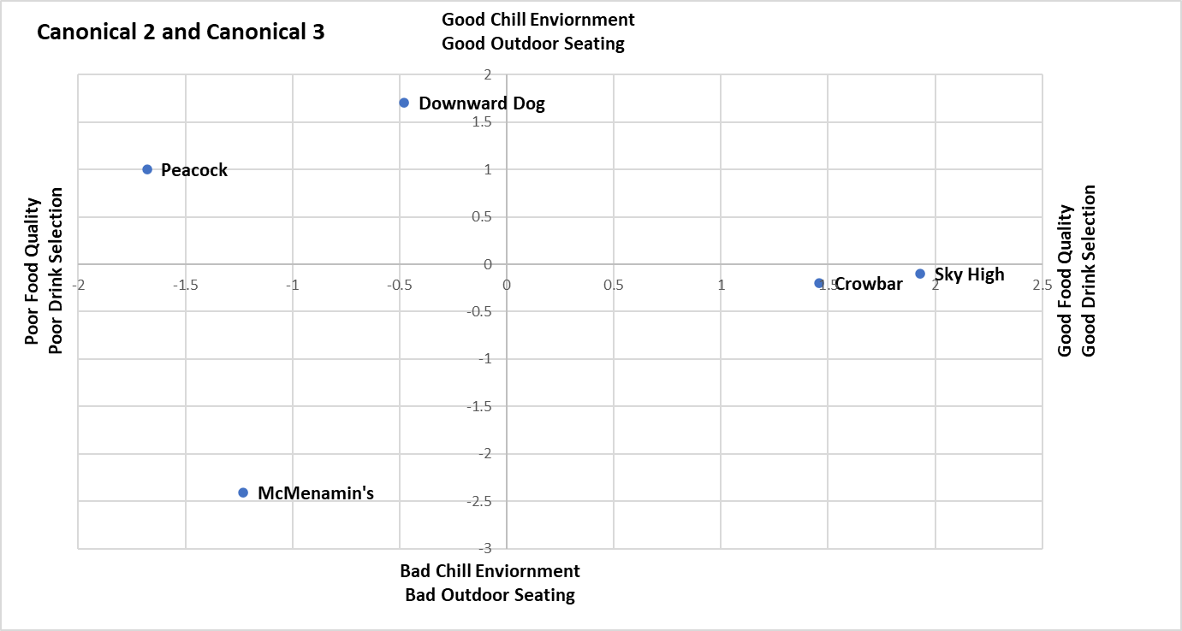

Based on these charts we can gather some information relating to what areas crowbar is good / bad in, and also who Crowbar's main competitors are. We can see that Crowbar is good at having good prices, Good food quality and good drink selection, while being poor in food selection and cleanliness. In terms of canonical 3 which consists of a good chill environment and good outdoor seating, Crowbar is essentially in the middle meaning canonical 3 is not very important when looking at crowbar.

Based on these charts, we can conclude that Crowbar's main competitors are Sky High and Peacock. This is because Crowbar overlaps with these 2 bars on a couple of the canonicals. Regarding Crowbar and Peacock, they both have good prices with bad food selection and poor cleanliness, however Crowbar does better than them in terms of food quality and drink selection. Peacock on the other hand provides a better environment with better outdoor seating compared to Crowbar. Whereas, Crowbar and Sky High have similar food quality and drink selection. However, Crowbar wins on prices, while Sky High has better cleanliness and food selection. Overall, based on these charts we can begin to make recommendations.

**Recommendations**

Crowbar should use this data to focus on the bars that have similarities to them ( Peacock and Sky High) rather than focusing on Downward dog and McMenamins. This is because in each canonical Crowbar and Downward dog / McMenamins are on the complete opposite sides of the spectrums. Instead, crowbar should think of how they may be able to differentiate their product from Peacock and Sky High.

In regards to canonical 1, it is recommended that they try to move closer to 0. This means they would lower their prices, while offering a better food selection and being more on top of cleanliness. However, to really differentiate themselves, they could keep their prices good while upgrading cleanliness and food selection. In doing this, they would potentially create a whole new spectrum where they would reign supreme as none of the other bars are doing this.

As for canonical 2, they likely should not change anything. In terms of their current competitors, they are already doing better than peacock in regards to canonical 2 while staying on par with Sky High. If they were to get worse in canonical 2, this would cause them to edge closer to Peacock and not be as differentiated in regards to the mix of canonical 1 and 2. Therefore, they should maintain their good food quality and drink selection.

Canonical 3 offers some room for improvement as well. If they were to upgrade their outdoor seating, they would likely in turn upgrade their chill environment as these variables seem to be linked. In doing so, they would come out ahead of Sky High in regards to this canonical.

Currently, they are more oriented towards a college crowd, which is completely fine. However, if they would like to expand their outreach, following these recommendations would likely keep them in tune with the college crowd, while offering themselves up to a more differentiated customer base. Overall, it is recommended that they keep their prices low, while improving upon cleanliness and food selection, as this will help expand to a new customer base while still maintaining their current customer base.